LOGIN INTO YOUR SCHOOL GOOGLE ACCOUNT / EMAIL

1. Click the waffle menu in the upper right from within a Google service such as Gmail, Drive, Calendar, etc.

2. Scroll down the list to the other apps area

3. Click the white Skyward Employee Access icon for the Skyward Financial System (employee access, time off, payroll, POs, etc.)
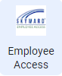

If you are logged into multiple Google accounts you might need to select your @deerfield.k12.wi.us account, but then you will be automatically logged in.

You are able to view Employee Information including Personal Information and Payroll including Check History, Direct Deposit, W-2, and W-4 among other information.
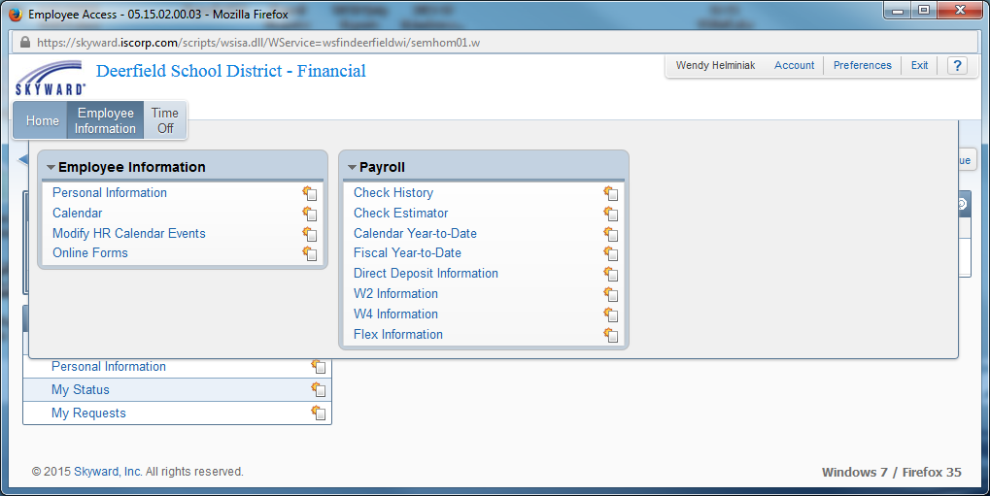

To View Time Office Status and Requests and Submit New Requests:
Time Off
- To view your time off status, click My Status
- To submit a new time off request, click My Requests
- Add
- Enter:
  - Time off code
  - Reason
  - Description; maybe instructions for calling in a sub
  - Date
  - Hours
  - Start Time
  - SAVE
- Supervisor and sub caller will receive an email notification
- When requesting emergency time off – Superintendent will receive email notification

**IMPORTANT**
- This process does not eliminate the need to notify school on days that you will be sick.
- If you are requesting time off within the next 24 hours, please email staffatt@deerfield.k12.wi.us to ensure a sub will be called.
- Do not call or schedule your own sub.
- Time off requests can be deleted or revised prior to the date requested.
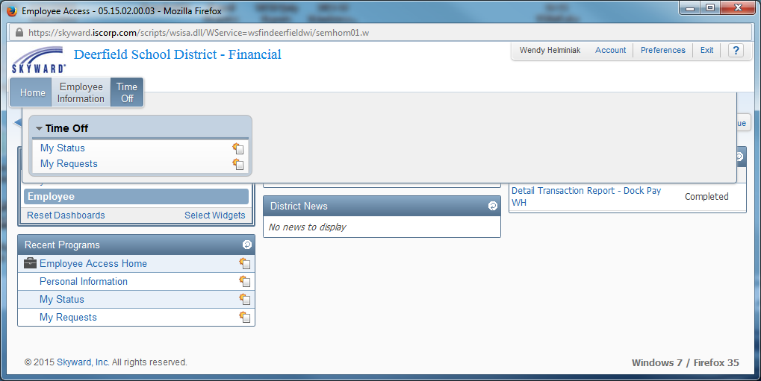
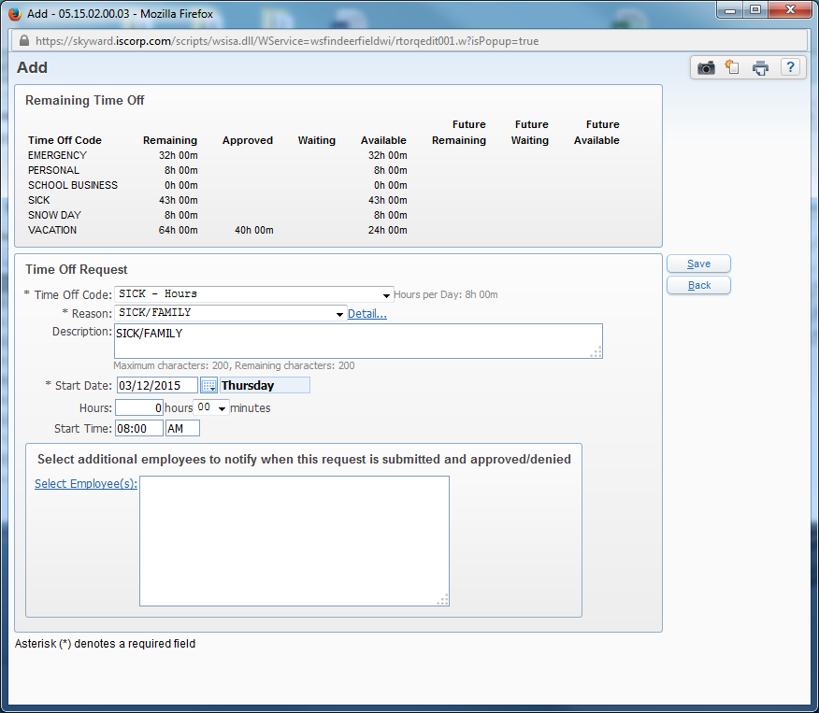
Questions? Please call Wendy Helminiak or Nathan Hruby

